**BANK DETAILS:**

create database swabank;

USE swabank ;

CREATE TABLE Branch (

    BranchName VARCHAR(30) PRIMARY KEY,

    BranchCity VARCHAR(30),

    Assets INT

);

INSERT INTO Branch VALUES

('SBI_Chamrajpet', 'Bangalore', 50000),

('SBI_ResidencyRoad', 'Bangalore', 10000),

('SBI_ShivajiRoad', 'Bombay', 20000),

('SBI_ParlimentRoad', 'Delhi', 10000),

('SBI_Jantarmantar', 'Delhi', 20000);

CREATE TABLE BankAccount (

    AccNo INT PRIMARY KEY,

    BranchName VARCHAR(30),

    Balance INT,

    FOREIGN KEY (BranchName) REFERENCES Branch(BranchName)

);

-- Inserting values into BankAccount

INSERT INTO BankAccount VALUES

(1, 'SBI_Chamrajpet', 2000),

(2, 'SBI_ResidencyRoad', 5000),

(3, 'SBI_ShivajiRoad', 6000),

(4, 'SBI_ParlimentRoad', 1000),

(5, 'SBI_Jantarmantar', 8000),

(6, 'SBI_ShivajiRoad', 4000),

(7, 'SBI_ResidencyRoad', 4000),

(8, 'SBI_ParlimentRoad', 3000),

(9, 'SBI_ResidencyRoad', 5000),

(10, 'SBI_ParlimentRoad', 3000),

(11, 'SBI_Jantarmantar', 2000);

CREATE TABLE BankCustomer (

    CustomerName VARCHAR(30) PRIMARY KEY,

    CustomerStreet VARCHAR(50),

    CustomerCity VARCHAR(30)

);

-- Inserting values into BankCustomer

INSERT INTO BankCustomer VALUES

('Avinash', 'Bull_Temple_Road', 'Bangalore'),

('Dinesh', 'Bannerghatta_Road', 'Bangalore'),

('Mohan', 'NationalCollege_Road', 'Bangalore'),

('Nikhil', 'Akbar_Road', 'Delhi'),

('Ravi', 'Prithviraj_Road', 'Delhi');

CREATE TABLE Deposit (

    CustomerName VARCHAR(30),

    AccNo INT,

    FOREIGN KEY (CustomerName) REFERENCES BankCustomer(CustomerName),

    FOREIGN KEY (AccNo) REFERENCES BankAccount(AccNo)

);

-- Inserting values into Deposit

INSERT INTO Deposit VALUES

('Avinash', 1),

('Dinesh', 2),

('Nikhil', 4),

('Ravi', 5),

('Avinash', 8),

('Nikhil', 9),

('Dinesh', 10),

('Nikhil', 11);

CREATE TABLE Loan (

    LoanNumber INT PRIMARY KEY,

    BranchName VARCHAR(30),

    Amount INT,

    FOREIGN KEY (BranchName) REFERENCES Branch(BranchName)

);

-- Inserting values into Loan

INSERT INTO Loan VALUES

(1, 'SBI_Chamrajpet', 1000),

(2, 'SBI_ResidencyRoad', 2000),

(3, 'SBI_ShivajiRoad', 3000),

(4, 'SBI_ParlimentRoad', 4000),

(5, 'SBI_Jantarmantar', 5000);

**QUERIES:**

-- Query 3

select BranchName, (Assets/100000)

as assets_in_lakhs

from branch;

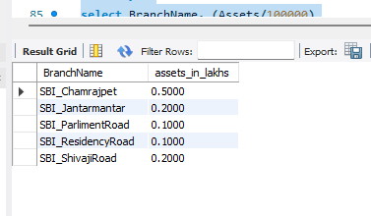

-- Query2

select CustomerName ,BranchName

from deposit,bankaccount

where deposit.Accno=bankaccount.Accno

group by customerName,branchName

HAVING count(bankaccount.Accno)>=2;

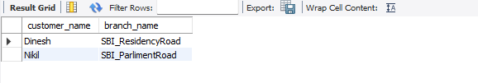

-- Query5

create view Branch_Loan_sum as

select BranchName,sum(Amount)

from loan

group by branchName;

select *

from Branch_Loan_Sum

